COMPUTER HARDWARE COMPONENTS

- Overview of Computer Hardware Components

- INTRODUCTION:

A computer has become an important part of our daily life. We use it for studying, office work, communication, gaming, designing, and many other activities. A computer cannot work with just one part; it is made up of different hardware components, and each one has a specific job. Components such as the motherboard, CPU, RAM, GPU, HDD, and SSD work together to make the computer fast, reliable, and efficient. Understanding these components helps us use, maintain, and upgrade a computer in a better way.

- WHAT IS COMPUTER HARDWARE?

Computer hardware refers to all the physical parts of a computer that we can see and touch. These components work together to process data, store information, and perform different tasks. Without hardware, a computer cannot function. Hardware works together with software to complete every operation.

- MAIN HARDWARE COMPONENTS AND THEIR FUNCTIONS

COMPONENTS | FUNCTION
1. Motherboard | Connects all hardware components.
2. CPU | Processes instructions.
3. RAM | Temporarily stores data.
4. GPU | Handles graphics and video rendering.
5. HDD | Stores data permanently.
6. SSD | Fast storage device.
7. SMPS | Supplies power to all components.

- LABELLED DIAGRAM OF A DESKTOP PC

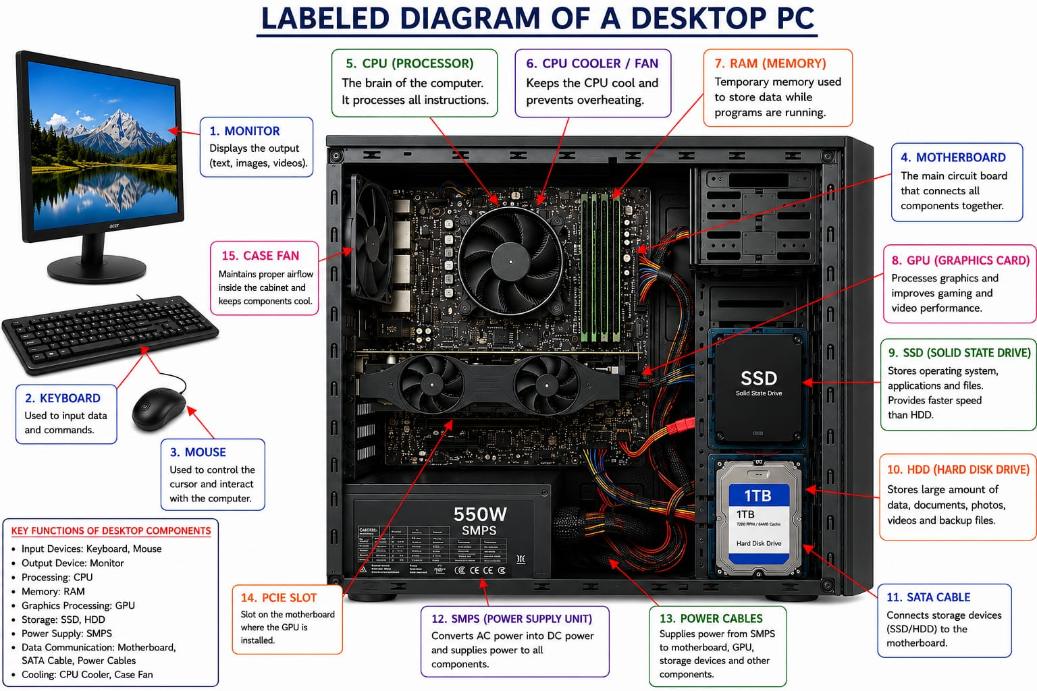

- COMPARISION BETWEEN HDD AND SSD

- INTRODUCTION:

Storage devices are used to save the operating system, applications, and personal files permanently. The two most common storage devices are the Hard Disk Drive (HDD) and the Solid State Drive (SSD). Although both perform the same basic function, they differ in terms of speed, durability, performance, and cost.

. FULL FORM OF HDD AND SSD IS :
- HDD – Hard Disk Drive
- SSD – Solid State Drive

- COMPARISON TABLE BETWEEN HDD AND SSD

FEATURE | HDD | SSD
1. Technology | Uses spinning magnetic disks. | Uses flash memo chips.
2. Speed | Slower. | Much faster.
Boot Time | Takes longer. | Boots quickly.
3. Durability | Less durable due to moving parts. | More durable because it has no moving parts.
4. Shock Resistance | Low. | High.
5. Noise | Produces noise. | Silent.
6. Power Consumption | Higher. | Lower.
7. Storage Capacity | Higher capacity lower cost. | Lower capacity at the same price.
8. Cost | Cheaper. | More expensive.
9. Best Use | File storage and backups. | Operating system, games, and software.

- TYPES OF HDD AND SSD WITH THEIR INTERNAL COMPONENTS.

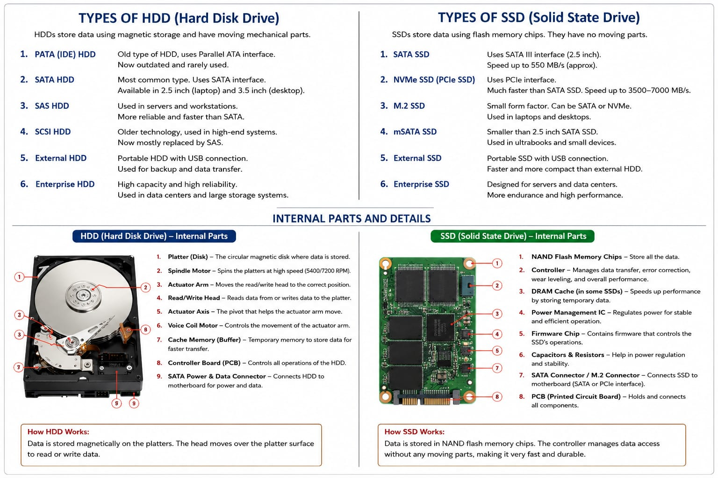

- CONCLUSION:
SSD is the better choice for users who need speed and fast performance, while HDD is suitable for storing large amounts of data at a lower cost. Many modern computers use both SSD and HDD to achieve a balance between speed and storage capacity.

- ROLE OF CPU, RAM, AND GPU IN GAMING.

- INTRODUCTION:

Playing games like PUBG and Free Fire on a computer requires different hardware components to work together. The CPU, RAM, and GPU each perform a unique role to ensure smooth gameplay, faster loading, and better graphics. If any one of these components is weak, the gaming experience may be affected.

- CPU (Central Processing Unit):

The CPU is known as the brain of the computer. It processes game instructions, controls player movements, manages AI, and handles background tasks. A powerful CPU helps games run smoothly without lag. The CPU also works together with Ram and GPU to provide smooth and stable gaming performance. Modern games perform better with a multi-core processor, such as Intel Core i5/i7 or AMD Ryzen5/7, depending on the game's requirements and graphics settings.

- RAM (Random Access Memory):
RAM temporarily stores the game's data while it is running. It allows the computer to quickly access files, maps, textures, and other game resources. More RAM improves loading speed and reduces stuttering during gameplay. Modern games usually perform better with at least 16 GB RAM.

- GPU (Graphics Processing Unit):
The GPU is responsible for rendering graphics, animations, lighting, and visual effects. It improves image quality and increases the frame rate (FPS), making the game smoother and more enjoyable. A dedicated GPU provides much better gaming performance than integrated graphics. A powerful GPU allows players to enjoy higher graphics settings, better visual quality, and smoother gameplay. A dedicated GPU is recommended for gaming because it provides better graphics quality, higher FPS (Frames Per Second), and smoother gameplay than an integrated GPU.

- CONCLUSION:

The CPU, RAM, and GPU are the three most important components for gaming. The CPU processes game logic, RAM stores temporary game data, and the GPU renders graphics. A balanced combination of these components provides smooth gameplay, faster loading times, and an enjoyable gaming experience.

- HARDWARE UPGRADES FOR SMOOTH FIFA GAMEPLAY

- INTRODUCTION:

The latest version of FIFA requires a computer with powerful and balanced hardware to deliver smooth gameplay, high-quality graphics, and stable performance. If a computer has old or low-end hardware, the game may experience lag, slow loading times, and lower frame rates (FPS). Upgrading the right hardware components improves the gaming experience and also enhances the overall performance of the computer.

- RECOMMENDED HARDWARE UPGRADES

- CPU (Central Processing Unit):

The CPU processes all game instructions, manages player movements, controls Artificial Intelligence (AI), and performs background tasks. Upgrading to a modern multi-core processor such as an Intel Core i5/i7 or AMD Ryzen 5/7 provides faster processing, reduces lag, and improves overall gaming performance.

- RAM (Random Access Memory):
RAM temporarily stores the game's data while it is running. Upgrading to 16 GB DDR4 or DDR5 RAM allows the game to load faster, improves multitasking, and reduces stuttering during gameplay. Modern games perform much better with at least 16 GB of RAM.

- GPU (Graphics Processing Unit):
A dedicated GPU is one of the most important upgrades for gaming. It renders graphics, textures, lighting, shadows, and visual effects. Upgrading to a dedicated graphics card such as an NVIDIA GeForce RTX or AMD Radeon RX improves image quality, increases FPS, and provides a smoother gaming experience than an integrated GPU.

- Storage (SSD):
Replacing an HDD with an NVMe SSD significantly improves system performance. Games load much faster, Windows starts quickly, and applications respond more smoothly. An SSD also improves overall system responsiveness.

- Power Supply (SMPS):
A higher-quality 80+ Certified SMPS provides stable and reliable power to all upgraded components. It protects the computer from power fluctuations and ensures stable performance during long gaming sessions.

- Cooling System:
Gaming generates a lot of heat, especially during long sessions. Installing a better CPU cooler and additional cabinet fans helps maintain safe temperatures, prevents overheating, and improves the lifespan of computer components.

- RECOMMENDED GAMING CONFIGURATION

COMPONENT | RECOMMENDED SPECIFICATION
1. CPU | Intel Core i5 (12th Gen+) /AMD Ryzen 5,7 or higher.
2. RAM | - B DDR4 or DDR5.
- GPU | NVDIA Get Force RTX 3060 / AMD Radeon RX 6600 or Higher.
- Storage | 512 GB NVME SSD.
- SMPS | 550W 80+ Bronze Certified.
- Operating System | Windows 11 (64-bit).

- BENEFIT OF UPGRADING

- Faster game loading time.
- Higher FPS (Frames Per Second).
- Better graphics quality.
- Reduced lag and stuttering.
- Improved multitasking.
- Better system stability.
- Longer hardware lifespan.

- CONCLUSION:

Upgrading the CPU, RAM, GPU, SSD, power supply, and cooling system creates a balanced gaming PC capable of running the latest version of FIFA smoothly. These upgrades not only improve gaming performance but also make the computer faster and more efficient for programming, video editing, cybersecurity, and everyday tasks.

